Logic Model¹
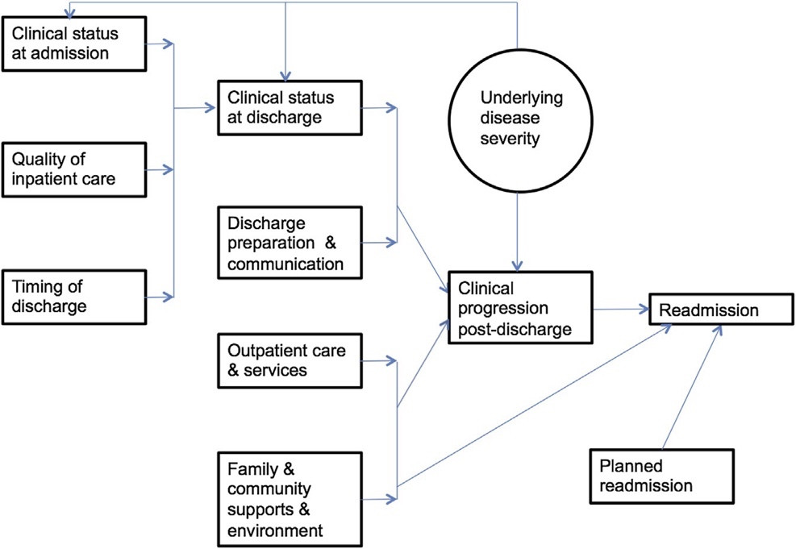
In many cases, readmissions signal how well disease is managed, indicating a worsening of health status that may have been prevented, and can reflect the quality of key processes, including discharge planning and education, care transitions, and follow-up care.
References
- Nakamura MM, Toomey SL, Zaslavsky AM, et al. Measuring pediatric hospital readmission rates to drive quality improvement. Acad Pediatr. 2014;14(5 Suppl):S39-S46. doi:10.1016/j.acap.2014.06.012

