**Supplemental Materials for CBE ID #4545e**

**Inappropriately Broad Empiric Antibiotic Selection for Adult Hospitalized Patients with Uncomplicated Community-Acquired Pneumonia**

**Section 1.26 Minimum Sample Size**

**Table 3.** Minimum annual number of qualifying cases needed for the denominator to reach each target reliability level at a given facility

| **Reliability**  **Threshold** | **Minimum number of annual cases needed** |
| --- | --- |
| 0.6 | 36 |
| 0.7 | 56 |
| 0.8 (standard) | 96 |
| 0.9 (high) | 216 |

Values are estimated using the Spearman Brown prophecy formula and based upon data from 109 Veterans Affairs (VA) facilities between Jan 2022 – June 2024. From these hospitals, we identified the following:

Total Variance: 3.4276

- Hospital Variance (signal): 0.1377

- Within Hospital Variance (noise): 3.2899

Median (IQR) number of eligible cases per hospital per year (2023): 135 [90-227]

Based on this information, an intraclass correlation (ICC) was calculated.

ICC=0.1377/(0.1377+3.2899)= 0.1377/3.4276=0.0402

Use the Spearman Brown Formula to obtain overall reliability of cohort

Example: For median annual cases of 135 (from VA 2023 data)

Median reliability: (135*0.0402)/(1+(135-1)* 0.0402)=0.850

**Section 2.3 Anticipated Impact**

**Figure 1.** Percentage of inappropriate broad spectrum antibiotic therapy in uncomplicated CAP across 69 Michigan hospitals.

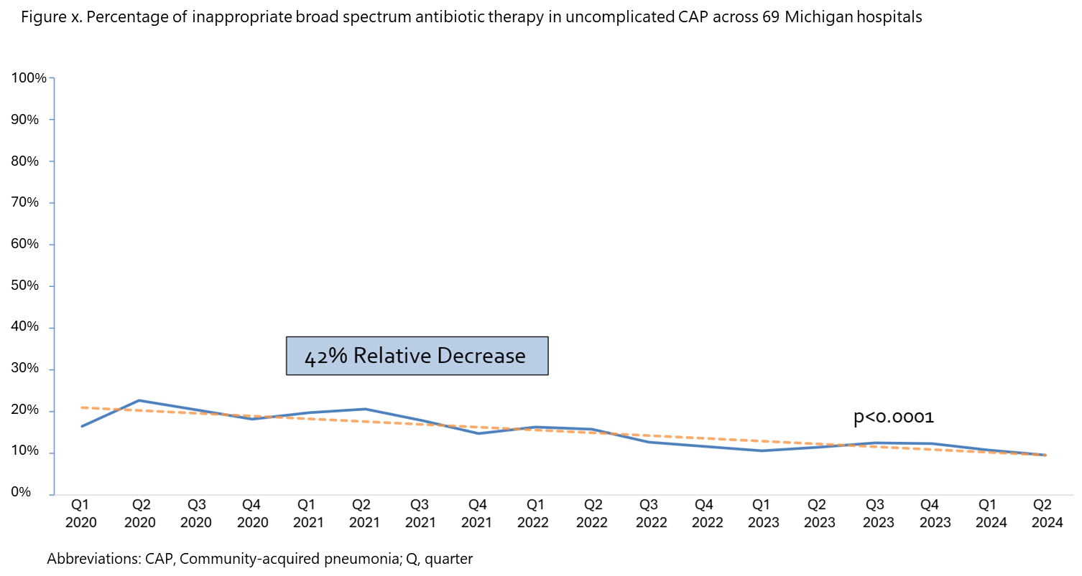

**Figure 2.** Distribution of class of antibiotic therapy in hospitalized VA patients from 2015 to 2024.

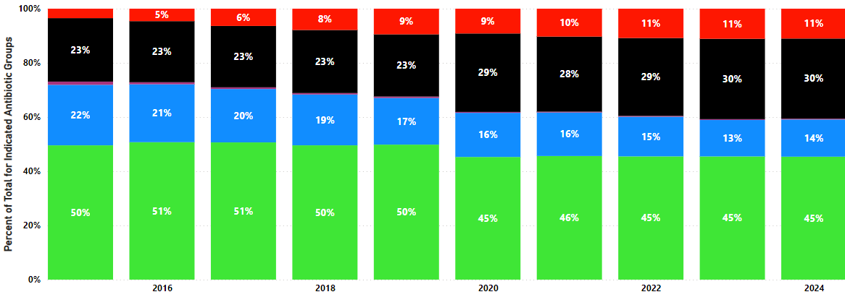

Key: Green = anti-*Pseudomonal* agents; blue = anti-MRSA agents; black = broad spectrum antibiotics for community onset infections; red = narrow-spectrum beta-lactam antibiotics

**Table 4.** Members of Technical Expert Panel (TEP) and the organizations they represented

| Name | Organization |
| --- | --- |
| Julio Ramirez, MD | Infectious Disease Society of America (IDSA) |
| Michelle Dardis, RN | The Joint Commission |
| Michael Pulia, MD, MS | Emergency Medicine; University of Wisconsin Madison |
| Marc Meyer, PharmD | American Society of Health-System Pharmacists (ASHP) |
| Jason Pogue, PharmD, BCPS, BCIDP | Society of Infectious Diseases Pharmacists (SIDP) |
| Kristina Crothers, MD | American Thoracic Society (ATS) |
| Liam Sullivan, DO | Society of Healthcare of America (SHEA) |
| Peter Lindenauer, MD, MSc, MHM, FACP | Society of Hospital Medicine (SHM) |
| Laura Feemster, MD, MS | American Thoracic Society (ATS) |

**Section 2.4 Performance Gap**

**Figure 3.** Percentage of patients hospitalized with CAP who received inappropriately broad empiric antibiotic therapy (as defined by our proposed eCQM) across 109 VA health care systems (1/1/2022-6/30/2024)

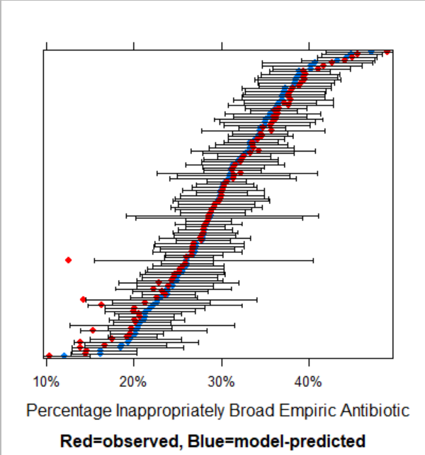

Each row of the above caterpillar plot represents a single VA health care system with the raw (unadjusted) percentage in red and the estimated percentage from a mixed effects logistic model with healthcare system random effects shown in blue (the bar represents the 95% confidence interval). Model-predicted estimates are shrunken towards the mean, meaning that the smaller the number of samples from a particular healthcare system, the more the estimate for that system is pulled toward the global mean.

**Table 5.** Inappropriately Broad Empiric Antibiotic Use for Uncomplicated CAP Across Sites

| * | **Michigan** 9/29/2015-12/22/2021 (n=5,553) | **Utah**  1/1/2021-5/30/2022  (n=619) | **109 VA Health Care Systems**  1/1/2022-6/30/2024  (n=47,034) |
| --- | --- | --- | --- |
| Received EITHER anti-MRSA or anti-Pseudomonal therapy in first 48 hours (**our proposed metric)** | 3,105 (55.9%) | 103 (16.6%) | 14,407 (30.6%) |
| Received anti-MRSA therapy in first 48 hours | 2,490 (44.8%) | 66 (10.7%) | 7,434 (15.8%) |
| Received anti-Pseudomonal therapy in first 48 hours | 2,933 (52.8%) | 65 (10.5%) | 13,165 (28.0%) |

*cell intentionally left empty

**Section 2.5 Health Care Quality Landscape**

**Table 6.** Sample of Current and Past Pneumonia and Antibiotic Use Clinical Quality Measures.22-24,46,55,56

| **Measure Name** | **Focus** | **Agency** | **Status** |
| --- | --- | --- | --- |
| CMIT 519 - Percent of Residents Assessed and Appropriately Given the Pneumococcal Vaccine (LS) | Process | Centers for Medicare & Medicaid Services | Active |
| NHSN Antimicrobial Use and Resistance (AUR) Module | Treatment | NHSN | Active |
| CBE-ID 4440e – Percent of Hospitalized Pneumonia Patients with Chest Imaging | Diagnosis | Partnership for Quality Measurement (PQM) | Endorsed 2023 |
| CBE-ID 3671 – Inappropriate Diagnosis of Community-Acquired Pneumonia in Hospitalized Medical Patients | Diagnosis | Partnership for Quality Measurement (PQM) | Endorsed 2021 |
| CBE2882 - Excess days in acute care (EDAC) after hospitalization for pneumonia | Length of Stay | Centers for Medicare & Medicaid Services | Endorsed 2021 |
| CBE 0506 – Hospital 30-day, All-Cause, Risk-Standardized Readmission Rate (RSRR) Following Pneumonia Hospitalization | Outcomes | Centers for Medicare & Medicaid Services | Endorsed 2021 |
| CBE 2579 – Hospital-level, risk-standardized payment associated with a 30-day episode of care for pneumonia (PN) | Cost | Centers for Medicare & Medicaid Services | Endorsed 2021 |
| CMIT 519 - Percent of Residents Assessed and Appropriately Given the Pneumococcal Vaccine (LS) | Process | Centers for Medicare & Medicaid Services | Active |
| 01508-02-C-MIPS – Simple Pneumonia with Hospitalization | Cost | CMS Merit-Based Incentive Payment System (MIPS) | Retired |
| PN-2 – Pneumococcal Vaccination | Prevention | The Joint Commission / CMS MIPS Value Pathways | Retired |
| PN-3b – Blood Cultures Performed in the Emergency Department Prior to Initial Antibiotic Received in Hospital | Diagnostic | The Joint Commission | Retired |
| PN-5 – Antibiotic Timing (Median) | Treatment | The Joint Commission | Retired |
| PN-5a – Initial Antibiotic Received Within 8 Hours of Hospital Arrival | Treatment | The Joint Commission | Retired |
| PN-5b – Initial Antibiotic Received Within 4 Hours of Hospital Arrival | Treatment | The Joint Commission | Retired |
| PN-5c – Initial Antibiotic Received Within 6 Hours of Hospital Arrival | Treatment | The Joint Commission | Retired |
| PN-6 – Initial Antibiotic Selection for Community-Acquired Pneumonia (CAP) in Immunocompetent Patients | Treatment | The Joint Commission | Endorsement removed |
| PN-7 – Influenza Vaccination | Prevention | The Joint Commission | Retired |
| CBE 0279 Community Acquired Pneumonia Admission Rate (PQI 11) | Incidence | Agency for Healthcare Research and Quality | Endorsement removed 2021 |
| CBE 0147 – Initial antibiotic selection for community-acquired pneumonia (CAP) in immunocompetent patients | Treatment | Centers for Medicare & Medicaid Services | Endorsement removed 2016 |
| CBE 0096 – Community-Acquired Bacterial Pneumonia (CAP): Empiric Antibiotic | Treatment | Physician Consortium for Performance Improvement | Endorsement removed 2017 |
| CBE 0140 – Ventilator-associated pneumonia for ICU and high-risk nursery (HRN) patients | Incidence | Centers for Disease Control and Prevention | Endorsement removed 2012 |
| **Measures for other conditions that may influence or be influence by proposed eCQM** | * | * | * |
| CBE 0500 -- Severe Sepsis and Septic Shock: Management Bundle / SEP-1 | Diagnosis/Treatment | Henry Ford Hospital | Endorsed 2021 |
| CBE 0058 – Avoidance of Antibiotic Treatment in Adults With Acute Bronchitis (AAB) | Treatment | National Committee of Quality Assurance | Endorsed 2021 |
| CBE 1891 - Hospital 30-day, all-cause, risk-standardized readmission rate (RSRR) following chronic obstructive pulmonary disease (COPD) hospitalization | Outcome | Centers for Medicare & Medicaid Services | Endorsed 2021 |
| CBE 1893 – Hospital 30-Day, all-cause, risk-standardized mortality rate (RSMR) following chronic obstructive pulmonary disease (COPD) hospitalization | Outcome | Centers for Medicare & Medicaid Services | Endorsed 2021 |
| CBE 2859 Pharmacotherapy Management of COPD Exacerbation | Treatment | National Committee of Quality Assurance | Endorsed 2021 |

*cells intentionally left empty

**Section 4.1.2 Differences in Data**

**Table 7**. Description of which data sources were used for each type of measure testing.

| **Measure Testing** | **Source Data** | **Dates** |
| --- | --- | --- |
| Accountable entity-level reliability: reliability for the entire hospital cohort | Electronic health record (EHR) data from 109 VA facilities | Jan, 2022 to June, 2024 |
| Accountable entity-level reliability: minimum case sample size | EHR data from 109 VA facilities | Jan, 2022 to June, 2024 |
| Encounter-level Validity: Comparison of eCQM empiric antibiotics with Case Review | Compared 540 patients with HMS chart review data from the University of Michigan with eCQM assessment in the University of Michigan | Sept 2015 to Dec 2021 |
| Encounter-level Validity: Comparison of eCQM measure results (% with inappropriate empiric antibiotic use) with Case Review | Compared 540 patients with HMS chart review data from the University of Michigan with eCQM assessment in the University of Michigan | Sept 2015 to Dec 2021 |
| Encounter-level Validity: Critical data element validity (and exclusions) | Compared inclusion/exclusion criteria and critical data element results between HMS chart review data and eCQM data for the University of Michigan. | Sept 2015 to Dec 2021 |
| Face Validity: National Expert Panel Feedback (n=8 experts) | Individuals from 8 national organizations participated in online technical expert panel (TEP) which involved discussion of measure. | April 2023 |
| Empirical Validity: Evaluated association with other measures of CAP antibiotic treatment quality | EHR data from 109 VA facilities | Jan, 2022 to June, 2024 |
| Empirical Validity: Evaluated association of empiric antibiotic use in CAP with outcomes | Literature review |  |
| Predictive Validity: Evaluated whether improvement in empiric antibiotic use in CAP results in improved patient outcomes. | Literature review |  |

**Section 4.1.3 Characteristics of Measured Entities**

**Table 8.** Characteristics of Measured Entities

| **Hospital Characteristic** | **University of Utah**  **N=1 hospital** | **VA Health Care System**  **N=109 hospitals** | **University of Michigan**  **N=1 hospital** |
| --- | --- | --- | --- |
| Data time frame | 1/1/2021 to 5/30/2022 | 1/1/2022 to 6/30/2024 | 9/29/2015 to 12/11/2021 |
| Academic Hospital | 1 (100%) | n/a | 1 (100%) |
| Location  Urban  Rural | 1 (100%)  0 (0%) | Healthcare systems span urban and rural areas | 1 (100%)  0 (0%) |
| Hospital Type  State  Federal | 1 (100%)  0 (0%) | 0 (0%)  109 (100%) | 1 (100%)  0 (0%) |
| Bed size  ≤50  51-100  101-200  >200 | 0  0  0  1 (100%) | 30 (27.5%)  24 (22.0%)  41 (37.6%)  14 (12.8%) | 0  0  0  1 (100%) |
| Annual patient census | 29,450 | 1,905,732* | 49,730 |

**Section 4.1.4 Characteristics of Units of the Eligible Population**

**Table 9.** Characteristics of VA patients in the testing dataset

| Variable | All Eligible Patients n=47034 | Inappropriate Empiric anti-MRSA or anti-*Pseudomonal*  n=14407 (30.6%) | No Inappropriate Empiric anti-MRSA or anti-*Pseudomonal*  n=32627 (69.4%) |
| --- | --- | --- | --- |
| Age, median (IQR) | 75 [68-81] | 75 [68 - 80] | 75 [68 - 81] |
| Sex | * | * | * |
| Male | 95.3% | 95.4% | 95.2% |
| Female | 4.7% | 4.6% | 4.8% |
| Race |  |  |  |
| White | 74.2% | 74.6% | 74.1% |
| Non-white | 25.8% | 25.4% | 25.9% |
| Co-morbidities | * | * | * |
| Elixhauser index IQR1 | 6 [1-11] | 7 [3 - 13] | 5 [1 - 11] |
| Acquired immune deficiency syndrome | 0.0% | 0.0% | 0.0% |
| Alcohol abuse | 5.8% | 5.4% | 6.0% |
| Deficiency anemia | 27.4% | 31.2% | 25.7% |
| Cardiac arrhythmias | 26.6% | 27.3% | 26.3% |
| Rheumatoid arthritis/collagen vascular diseases | 3.0% | 3.4% | 2.8% |
| Blood-loss anemia | 0.7% | 0.8% | 0.7% |
| Congestive heart failure | 22.2% | 23.2% | 21.7% |
| Chronic pulmonary disease | 46.0% | 46.9% | 45.6% |
| Coagulopathy | 5.7% | 6.8% | 5.2% |
| Depression | 7.8% | 7.5% | 7.9% |
| Diabetes, uncomplicated | 14.4% | 14.5% | 14.3% |
| Diabetes, complicated | 24.1% | 24.3% | 24.0% |
| Drug abuse | 5.6% | 5.1% | 5.8% |
| Hypertension without complications | 35.3% | 34.4% | 35.7% |
| Hypertension with complications | 33.4% | 33.9% | 33.2% |
| Liver disease | 7.4% | 8.1% | 7.0% |
| Lymphoma | 0.0% | 0.1% | 0.0% |
| Metastatic cancer | 5.8% | 9.8% | 4.0% |
| Solid tumor without metastasis | 7.7% | 9.9% | 6.8% |

Abbreviations: IQR, interquartile range

1The Elixhauser comorbidity index is a composite of 38 comorbidities operationalized by the Agency for Healthcare Research and Quality (AHRQ) to predict 30-day, in-hospital, and 1-year mortality in older adults.75

*cells intentionally left empty

**Table 10.** Characteristics of the University of Michigan patients in the testing dataset.

| Variable | All Eligible Patients n=5,553 | Inappropriate Empiric anti-MRSA or anti-*Pseudomonal*  n=3105 (55.9%) | No Inappropriate Empiric anti-MRSA or anti-*Pseudomonal*  n=2448 (44.1%) |
| --- | --- | --- | --- |
| Age median (IQR) | 64 (52-75) | 65 (53-75) | 64 (50-75) |
| <65 years | 2795 (50.3%) | 1536 (49.5%) | 1259 (51.4%) |
| 65-74 years | 1287 (23.2%) | 737 (23.7%) | 550 (22.5%) |
| > 75 years | 1471 (26.5%) | 832 (26.8%) | 639 (26.1%) |
| Gender, n (%) | * | * | * |
| Female | 2683 (48.3%) | 1487 (47.9%) | 1196 (48.9%) |
| Male | 2870 (51.7%) | 1618 (52.1%) | 1252 (51.1%) |
| Race | * | * | * |
| Black | 774 (13.9%) | 411 (13.2%) | 262 (14.8%) |
| Other | 364 (6.6%) | 199 (6.4%) | 165 (6.7%) |
| White | 4415 (79.5%) | 2495 (80.4%) | 1920 (78.4%) |
| Ethnicity | * | * | * |
| Hispanic | 131 (2.4%) | 78 (2.5%) | 53 (2.2%) |
| Non-Hispanic | 5348 (96.3%) | 2998 (96.6%) | 2350 (96.0%) |
| Unknown | 74 (1.3%) | 29 (0.9%) | 45 (1.8%) |
| Comorbidities | * | * | * |
| Influenza | 38 (0.7%) | 14 (0.5%) | 24 (1.0%) |
| COPD | 1627 (29.3%) | 889 (28.6%) | 738 (30.1%) |
| Lung Cancer | 817 (14.7%) | 605 (19.5%) | 212 (8.7%) |
| Home oxygen | 237 (4.3%) | 160 (5.2%) | 77 (3.1%) |
| Chemotherapy | 395 (7.1%) | 304 (9.8%) | 91 (3.7%) |
| Immunosuppressants | 268 (4.8%) | 213 (6.9%) | 55 (2.2%) |
| Chronic Steroids | 207 (3.7%) | 143 (4.6%) | 64 (2.6%) |
| Immunosuppression1 | 706 (12.7%) | 525 (16.9%) | 181 (7.4%) |
| Nephrotic Syndrome | 30 (0.5%) | 16 (0.5%) | 14 (0.6%) |
| Emphysema | 769 (13.8%) | 428 (13.8%) | 341 (13.9%) |
| Congenital/Acquired Immunodeficiency | 377 (6.8%) | 262 (8.4%) | 115 (4.7%) |
| Length of Stay, median (IQR) | 5 (3-8) | 5 (4-8) | 4 (3-7) |

Abbreviations: IQR, interquartile range; COPD, chronic obstructive lung disease

1defined as having chemotherapy, immunosuppressants, or chronic steroids

*cells intentionally left empty

**Table 11.** Characteristics of the University of Utah patients in the testing dataset.

| Variable | All Eligible Patients n=619 | Inappropriate Empiric anti-MRSA or anti-*Pseudomonal*  n=103 (39.9%) | No Inappropriate Empiric anti-MRSA or anti-*Pseudomonal*  n=516 (60.1%) |
| --- | --- | --- | --- |
| Age. median (IQR) | 62 (47-75) | 58 (44-72) | 63 (48-76) |
| <65 years, n(%) | 336 (54.3) | 65 (63.1) | 271 (52.5) |
| 65-74 years, n(%) | 119 (19.2) | 19 (18.4) | 100 (19.4) |
| > 75 years, n(%) | 164 (26.5) | 19 (18.4) | 145 (28.1) |
| Gender, n(%) | * | * | * |
| Female | 299 (48.3) | 52 (50.5) | 247 (47.9) |
| Male | 320 (51.7) | 51 (49.5) | 269 (52.1) |
| Race, n(%) | * | * | * |
| White | 472 (78.7) | 75 (75.0) | 397 (79.4) |
| Black | 11 (1.8) | 3 (3.0) | 8 (1.6) |
| American Indian/Alaska Native | 8 (1.3) | 4 (4.0) | 4 (0.8) |
| Asian | 13 (2.2) | 1 (1.0) | 12 (2.4) |
| Native Hawaiian/Pacific Islander | 14 (2.3) | 4 (4.0) | 10 (2.0) |
| Hispanic/Latino | 37 (6.2) | 4 (4.0) | 33 (6.6) |
| Other | 34 (5.7) | 7 (7.0) | 27 (5.4) |
| Unknown/not reported | 11 (1.8) | 2 (2.0) | 9 (1.8) |
| Ethnicity, n(%) | * | * | * |
| Hispanic | 79 (12.8) | 13 (12.7) | 66 (12.8) |
| Non-Hispanic | 522 (84.7) | 88 (86.3) | 434 (84.4) |
| Unknown/not reported | 15 (2.5) | 1 (1.0) | 14 (2.7) |
| Comorbidities, n(%) | * | * | * |
| COPD | 117 (18.9) | 12 (11.7) | 105 (20.3) |
| Chronic kidney disease | 3 (0.5) | 2 (1.9) | 1 (0.2) |
| Lung cancer | 56 (9.0) | 13 (12.6) | 43 (8.3) |
| Emphysema | 50 (8.1) | 3 (2.9) | 47 (9.1) |
| Acquired or congenital immunodeficiency | 32 (5.2) | 15 (14.6) | 17 (3.3) |
| Length of Stay Median (IQR) | 4 (2-6) | 4 (2-7) | 4 (2-6) |

Abbreviations: IQR, interquartile range; COPD, chronic obstructive lung disease

1defined as having chemotherapy, immunosuppressants, or chronic steroids

*cells intentionally left empty

**Section 4.3.2**

**Table 12.** Summary of validity testing during measure development

| **Type of Validity** | **Description** | **Results** | **Interpretation** |
| --- | --- | --- | --- |
| **During Measure Development** | * | * | * |
| A. Face Validity- National Guidelines | Based on National Guidelines | ATS/IDSA CAP Guidelines10  CDC Core Elements of Hospital Antibiotic Stewardship Programs34 | Initial basis for definitions |
| B. Face Validity- Expert Feedback | Data Design and Publications Committee (HMS)  TEP | Refined inclusion/exclusion criteria and measure specifications to current form | Measure refinement to current measure specifications |
| **On Final Measure** | * | * | * |
| C. Encounter-level Validity: Comparison of eCQM empiric therapy with Case Review | Compared 540 patients with HMS chart review data from the University of Michigan with eCQM assessment in the University of Michigan. | 96.7% (522/540) accurately identified which empiric antibiotics had been received (i.e., no anti-MRSA/pseudomonal, only anti-MRSA, only anti-*Pseudomonal*, and both anti-MRSA/Pseudomonal). | Substantial agreement between eCQM and chart review on whether the patient received empiric broad spectrum antibiotic therapy |
| D. Encounter-level Validity: Comparison of eCQM measure results (% with inappropriate empiric therapy) with Case Review | Compared 540 patients with HMS chart review data from the University of Michigan with eCQM assessment in the University of Michigan. | Of the 540 patients, 50.7% (294) received inappropriate anti-MRSA OR anti-pseudomonal therapy using HMS definition (chart review; gold standard); 53.0% received inappropriate anti-MRSA OR anti-pseudomonal therapy using eCQM data  Considering HMS chart review as the gold standard, the sensitivity of the eCQM was **96% (274/286)**, and specificity of the eCQM was **92% (234/254**). | Compared to chart review, measure has high sensitivity and specificity identifying patients with inappropriate broad spectrum empiric antibiotics |
| E. Encounter-level Validity: Critical data element validity | Initial exclusions were compared across the University of Michigan, University of Utah, and the VA healthcare system.  Compared inclusion/ exclusion criteria and critical data element results between HMS chart review data and eCQM data for the University of Michigan. | The percentage of patients excluded, by individual element and overall, was similar across the University of Michigan, University of Utah, and the VA health care systems.  Generally, sensitivity and specificity were high for all empiric-specific exclusions (see detailed results below) with the exception of the modified severity criteria (used for exclusion with hospitalization with prior IV antibiotic use) which had a sensitivity of 86.9% and specificity of 77.9% but were much more feasible for all of our health systems (see more details in feasibility) | Used modified definition of severe CAP to improve feasibility; otherwise, critical data elements had high sensitivity and specificity |
| F. Face Validity: National Expert Panel Feedback (N=8 experts) | Individuals from 8 national organizations participated in online TEP which involved discussion of measure. | TEP members agreed with face validity. Additional questions/data requests were answered, and responses included below.  Survey Question:  “The [measure] can be used to distinguish between better and worse performing hospitals.” Likert (1=Strongly disagree, 5=Strongly agree)  4/7 respondents (57.1) reported “Agree”; 1/7(14.3%) reported “Strongly agree”; 2/7 (28.6%) reported “Neutral” | High face validity  Noted that optimal level of inappropriate empiric broad spectrum antibiotic use should not be 0%. |
| G. Empirical Validity: Evaluated association with other measures of CAP antibiotic treatment quality | Evaluated association at hospital level between CAP excess duration and CAP inappropriately broad-spectrum antibiotic use. | Hospitals with higher rates of excess duration also had higher rates of inappropriate use of broad spectrum antibiotics for CAP; R=0.29, p=0.002 (i.e., weak positive correlation) | Hospitals performing better on this measure were also better at appropriate antibiotic treatment duration for CAP |
| H. Empirical Validity: Evaluated association of inappropriately broad empiric treatment in CAP with outcomes | Reviewed published literature on patient outcomes associated with inappropriately broad empiric treatment in CAP | After adjustment, inappropriately broad empiric treatment was associated with higher 30-day readmissions, more transfers to ICU, longer hospitalizations, and more antibiotic-associated adverse events.11  Among 88,605 CAP patients across the Veterans Health Administration health care system, empirical anti-MRSA therapy in addition to standard CAP therapy was associated with an increased adjusted risk of death, kidney injury, and secondary infections (*C. difficile,* vancomycin-resistant enterococcal infection, and gram-negative rod infections) compared to standard CAP treatment alone.8 | Inappropriately broad empiric treatment for CAP is associated with antibiotic-related harm |
| I. Predictive Validity: Evaluated whether improvement in inappropriately broad empiric treatment results in improved patient outcomes. | Reviewed published literature on how patient outcomes change with reductions in inappropriately broad empiric treatment in CAP | The effect of reducing inpatient broad-spectrum antibiotic exposure was modeled and estimated that reduction in use of broad-spectrum antibiotics by 30% could result in a 26% reduction in *C. difficile* infection.2 | Reducing inappropriately broad empiric treatment of CAP may reduce antibiotic-related harm |

Abbreviations: RCT, randomized clinical trial; ATS, American Thoracic Society; IDSA, Infectious Disease Society of America; CAP, community-acquired pneumonia; HMS, Michigan Hospital Medicine Safety Consortium; TEP, technical expert panel; aOR, adjusted odds ratio

*cells intentionally left empty