**Section 4.3.4 Validity Testing Results**

**Table 13.** Total antibiotic duration comparison for UM HMS manually abstracted data (gold standard) to UM eCQM in 450 CAP patients

| Total Duration | UM HMS  <5 days | UM HMS  5 days | UM HMS  6 days | UM HMS  7 days | UM HMS  8 days | UM HMS  >8 days |
| --- | --- | --- | --- | --- | --- | --- |
| UM eCQM  <5 days | 14 (3.1%) | 0 | 0 | 1 (0.2%) | 0 | 2 (0.4% |
| UM eCQM  5-5.5 days | 0 | 62 (13.8%) | 5 (1.1%) | 3 (0.7%) | 0 | 0 |
| UM eCQM  6-6.5 days | 0 | 4 (0.9%) | 81 (18.0%) | 1 (0.2%) | 0 | 3 (0.7%) |
| UM eCQM  7-7.5 days | 1 (0.2%) | 0 | 3 (0.7%) | 78 (17.3%) | 3 (0.7%) | 3 (0.7%) |
| UM eCQM  8-8.5 days | 0 | 1 (0.2%) | 1 (0.2%) | 1 (0.2%) | 71 (15.8%) | 4 (0.9%) |
| UM eCQM  >8.5 days | 0 | 0 | 0 | 1 (0.2%) | 2 (0.4%) | 105 (23.3%) |

411/450 (91.3%) in green were accurate within a ½ day; 434/450 (96.4%) green/yellow were accurate within 1.5 days

Abbreviations: CAP, community-acquired pneumonia; UM, University of Michigan; HMS, Michigan Hospital Medicine Safety Consortium

**Table 14.** Inpatient antibiotic duration comparison for UM HMS manually abstracted data (gold standard) to UM eCQM in 450 CAP patients

| Inpatient Duration | UM HMS  <5 days | UM HMS  5 days | UM HMS  6 days | UM HMS  7 days | UM HMS  8 days | UM HMS  >8 days |
| --- | --- | --- | --- | --- | --- | --- |
| UM eCQM  <5 days | 278 (61.2%) | 1 (0.2%) | 3 (0.7%) | 0 | 0 | 0 |
| UM eCQM  5-5.5 days | 0 | 82 (18.1%) | 1 (0.2%) | 1 (0.2%) | 0 | 1 (0.2%) |
| UM eCQM  6-6.5 days | 0 | 1 (0.2%) | 47 (10.4%) | 2 (0.4%) | 0 | 0 |
| UM eCQM  7-7.5 days | 0 | 0 | 2 (0.4%) | 18 (4.0%) | 1 (0.2%) | 2 (0.4%) |
| UM eCQM  8-8.5 days | 0 | 0 | 0 | 0 | 11 (2.4%) | 0 |
| UM eCQM  >8.5 days | 0 | 0 | 0 | 0 | 0 | 3 (0.7%) |

439/454 (96.7%) in green were accurate within a ½ day; 447/454 (98.5%) green/yellow were accurate within 1.5 days

Abbreviations: CAP, community-acquired pneumonia; UM, University of Michigan; HMS, Michigan Hospital Medicine Safety Consortium

**Table 15.** Discharge antibiotic duration comparison for UM HMS manually abstracted data (gold standard) to UM eCQM in 450 CAP patients

| Discharge Duration | UM HMS  0 days | UM HMS  1 day | UM HMS  2 days | UM HMS  3 days | UM HMS  4 days | UM HMS  5 days | UM HMS  6 days | UM HMS  >6 days |
| --- | --- | --- | --- | --- | --- | --- | --- | --- |
| UM eCQM  0-0.5 days | 85 (18.9%) | 0 | 0 | 1 (0.2%) | 1 (0.2%) | 0 | 2 (0.4%) | 0 |
| UM eCQM  1-1.5 | 1 (0.2%) | 28 (6.1%) | 2 (0.4%) | 2 (0.4%) | 0 | 0 | 0 | 0 |
| UM eCQM  2-2.5 | 0 | 0 | 52 (11.4%) | 1 (0.2%) | 1 (0.2%) | 2 (0.4%) | 0 | 0 |
| UM eCQM  3-3.5 | 1 (0.2%) | 1 (0.2%) | 2 (0.4%) | 70 (15.3%) | 0 | 0 | 0 | 1 (0.2%) |
| UM eCQM  4-4.5 | 1 (0.2%) | 1 (0.2%) | 1 (0.2%) | 1 (0.2%) | 67 (14.6%) | 0 | 0 | 0 |
| UM eCQM  5-5.5 | 1 (0.2%) | 0 | 1 (0.2%) | 0 | 1 (0.2%) | 74 (16.2%) | 0 | 0 |
| UM eCQM  6-6.5 | 0 | 0 | 1 (0.2%) | 0 | 0 | 0 | 19 (4.2%) | 0 |
| UM eCQM  >6.5 | 3 (0.7%) | 0 | 0 | 1 (0.2) | 0 | 1 (0.2%) | 0 | 32 (7.0%) |

427/458 (93.2%) in green were accurate within a ½ day; 435/458 (95.0%) green/yellow were accurate within 1.5 days

Abbreviations: CAP, community-acquired pneumonia; UM, University of Michigan; HMS, Michigan Hospital Medicine Safety Consortium

**Table 16.** Sensitivity and Specificity of the eCQM in assessing excess antibiotic duration

| **n=450 patients** | UM eCQM (electronic)  n (%) | UM HMS data (chart review)  n (%) | Sensitivity of UM eCQM (vs. UM HMS chart review) | Specificity of UM eCQM (vs. UM HMS chart review) |
| --- | --- | --- | --- | --- |
| Received ≥7 days total antibiotic duration | 281 (61.4%) | 278 (60.7%) | **96% (268/278)** | **93% (167/180)** |

Excess antibiotic duration is defined as receiving >=7 days total antibiotic duration in patients considered eligible for a 5-day duration according to national guidelines

Abbreviations: UM, University of Michigan; HMS, Michigan Hospital Medicine Safety Consortium

**Table 17**. Denominator exclusions to define the population: Hospitalized non-ICU adults with CAP; comparison of measured entities

| **Exclusion** | **Michigan**  **(n=49,205)** | **Utah**  **(n=5,909)** | **VA**  **(n=102,416)** |
| --- | --- | --- | --- |
| Under 18 on admission | 8,905 (18.1%) | 0 | 0 |
| Patient class NOT inpatient or observation | 4,289 (8.7%) | 908 (15.4%) | NA |
| Died in the first 48 hours of hospitalization | 709 (1.4%) | 133 (2.3%) | 418 (0.4%) |
| Any time in ICU in the first 48 hours of hospitalization | 10,910 (22.2%) | 2391 (40.5%) | 17512 (17.1%) |
| Admitted from another hospital or long-term acute care facility | 1,272 (2.6%) | 1,506 (25.5%) | 7153 (7.0%) |
| Concurrent infection by ICD10 | 7,903 (16.1%) | 2,424 (41.0%) | 24719 (24.1%) |
| Chest imaging required (day -3 to day 3 of admission) | 465 (0.9%) | 726 (12.3%) | 2189 (2.1%) |
| **Ending population** | **10,366 (21.1%)** | **1049 (17.8%)** | **60,943 (59.5%)** |

Abbreviations: ICU, intensive care unit; CAP, community-acquired pneumonia

**Table 18.** Exclusions to Narrow Population to Uncomplicated CAP

| **Exclusion** | **Michigan (n=10,366)** | **Utah**  **(n=1049)** | **VA**  **(n=60,943)** |
| --- | --- | --- | --- |
| Cystic Fibrosis | 286 (2.8%) | 19 (1.8%) | 18 (0.0%) |
| On mechanical ventilation in first 48 hours of hospitalization | 690 (6.7%) | 46 (4.4%) | NA |
| Absolute neutrophil count <500 cells/uL | 443 (4.3%) | 81 (7.7%) | 111 (0.2%) |
| Bronchiectasis | 791 (7.6%) | 58 (5.5%) | 2803 (4.6%) |
| HIV (irrespective of CD4) | 52 (0.5%) | 26 (2.5%) | 978 (1.6%) |
| Tracheostomy | 384 (3.7%) | 20 (1.9%) | 633 (1.0%) |
| Transplant in prior year | 1522 (14.7%) | 150 (14.3%) | 1478 (2.4%) |
| Hematologic malignancy | 1461 (14.1%) | 180 (17.2%) | 4762 (7.8%) |
| Pulmonary complication: | 263 (2.5%) | 38 (3.6%) | 1698 (2.8%) |
| **Ending population** | **6,285 (60.6%)** | **655 (62.4%)** | **49,774 (81.7%)** |

**Table 19.** Denominator exclusions specific to calculation of duration

| **Exclusion** | **Michigan (n=6285)** | **Utah**  **(n=655)** | **VA**  **(n 49774)** |
| --- | --- | --- | --- |
| Cannot calculate duration | * | * | * |
| Died during hospitalization | 223 (3.5%) | 7 (1.1%) | 830 (1.7%) |
| Discharged to another hospital | 20 (0.3%) | 6 (0.9%) | 2994 (6.0%) |
| Discharged to inpatient/home hospice | 284 (4.5%) | 30 (4.6%) | 333 (0.7%) |
| Appropriate Duration May be Longer | * | * | * |
| Transferred to ICU during hospitalization | 253 (4.0%) | 44 (6.7%) | 4262 (8.6%) |
| Bacteremic with non-skin commensal | 317 (5.0%) | 0 | 1085 (2.8%) |
| *Staphylococcus aureus* in respiratory culture | 123 (2.0%) | 3 (0.5%) | 810 (1.6%) |
| *Pseudomonas aeruginosa* in respiratory culture | 92 (1.5%) | 2 (0.3%) | 665 (1.4%) |
| Legionella pneumonia | 24 (0.4%) | 4 (0.6%) | 583 (1.2%) |
| Time to clinical stability >5 days | 779 (12.4%) | 2 (0.3%) | 209 (1.3%) |
| Condition likely not CAP | * | * | * |
| Received <3 days of antibiotics | 1166 (18.6%) | 192 (29.3%) | 13061 (25.4%) |
| >14-day total antibiotic duration | 414 (6.6%) | 92 (14.0%) | 1561 (3.2%) |
| **Ending population** | **3437 (54.7%)** | **313 (47.8%)** | **28,238 (56.7%)** |

*cell intentionally left empty

**Table 20.** Sensitivity/Specificity of Exclusion Criteria Comparing eCQM and Chart Review (UM, n=592)

| **\*** | UM eCQM data (electronic) n (%) | UM HMS data (chart review) n (%) | Sensitivity of UM eCQM (vs. UM HMS chart review) | Specificity of UM eCQM (vs. UM HMS chart review) |
| --- | --- | --- | --- | --- |
| **Duration-specific Exclusions** | n=592 | n=592 | n=592 | n=592 |
| Died during hospitalization | 2 (0.3%) | 2 (0.3%) | 100% (2/2) | 100% (590/590) |
| Discharged to another hospital | 2 (0.3%) | 1 (0.2%) | 100% (1/1) | 99% (590/591) |
| Discharged to inpatient/home hospice | 3 (0.5%) | 2 (0.3%) | 100% (2/2) | 99% (589/590) |
| Transferred to ICU during hospitalization | 9 (1.5%) | 9 (1.5%) | 88.9% (8/9) | 99% (582/583) |
| Bacteremic with non-skin commensal | 11 (1.9%) | 8 (1.4%) | 88% (7/8) | 99% (580/584) |
| *Staph Aureus* in respiratory culture | 18 (3.0%) | 17 (2.9%) | 100% (17/17) | 99% (574/575) |
| *Pseudomonas* in respiratory culture | 14 (2.4%) | 13 (2.2%) | 100% (13/13) | 99% (578/579) |
| Legionella pneumonia | 4 (0.7%) | 4 (0.7%) | 100% (4/4) | 100% (588/588) |
| Time to clinical stability >5 days1 | 37 (6.3%) | 93 (15.7%) | 29% (27/93) | 98% (489/499) |
| Received <3 days of antibiotics | 35 (5.9%) | 31 (5.2%) | 100% (31/31) | 99% (557/561) |
| >14-day total antibiotic duration | 25 (4.2%) | 24 (4.1%) | 88% (21/24) | 99% (564/568) |

*cell intentionally left empty

1Here, we compare the eCQM’s simplified definition of clinical stability (afebrile and SBP ≥90 mmHg or discharged) to the original definition of stability (no more than 1 sign of clinical stability). Though the sensitivity is much lower, the feasibility of this specification was much higher across all three systems (see feasibility discussion for more details).

**Figure 3.** Relationship between excess antibiotic duration and inappropriately broad empiric antibiotic use.

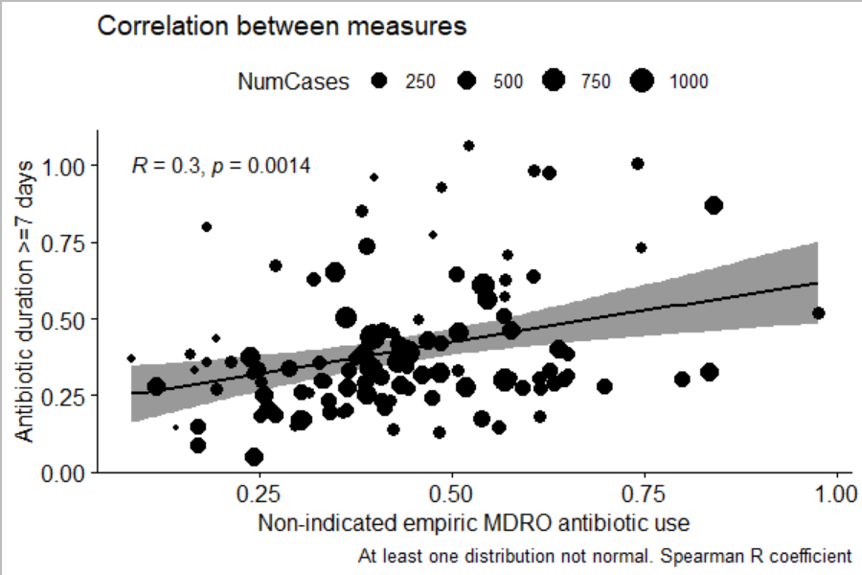

MDRO= Multi-Drug-Resistant Organisms

Patient data from 109 VA hospitals between January 1, 2022 and June 30, 2024. Each hospital is represented as a dot with larger hospitals having larger dots.

**Table 21.** Association of Excess Antibiotic Treatment Duration With 30-Day Adverse Outcomes (n = 6481)15

| **Outcomes at 30 Days** | **Appropriate Duration (n=2090),**  **n(%)** | **Excess Duration (n=4391),**  **n(%)** | **Unadjusted OR per Excess Day**  **(95% CI)** | **Unadjusted P Values** | **Adjusted OR per Excess Day**  **(95% CI)** | **Adjusted P Value** |
| --- | --- | --- | --- | --- | --- | --- |
| Mortality | 40 (1.9) | 88 (2.0) | 0.99 (0.94-1.03) | 0.52 | 1.01 (0.97–1.05) | 0.60 |
| Readmission | 294 (14.1) | 497 (11.3) | 0.99 (0.96-1.02) | 0.48 | 1.00 (0.98–1.03) | 0.92 |
| Emergency department visit | 238 (11.4) | 480 (10.9) | 0.97 (0.94-1.00) | 0.021 | 0.98 (0.95–1.01) | 0.166 |
| Antibiotic-associated adverse event | 72 (3.4) | 210 (4.8) | 1.04 (1.01-1.07) | 0.012 | 1.03 (1.00–1.06) | **0.038** |
| C. difficile infection | 11 (0.5) | 22 (0.5) | 0.92 (0.81-1.05) | 0.21 | 0.93 (0.81–1.07) | 0.30 |
| Provider-documented | 32 (2.1) | 87 (2.0) | 1.00 (0.94-1.05) | 0.86 | 0.99 (0.94–1.05) | 0.85 |
| Patient-reported | 26/1132 (2.3) | 114/2460 (4.6) | 1.05 (1.02-1.08) | <0.001 | 1.05 (1.02–1.08) | **0.001** |
| Composite adverse outcome | 499 (23.9) | 897 (20.4) | 0.98 (0.96-1.00) | 0.078 | 0.99 (0.97–1.01) | 0.40 |

OR = odds ratio.

Outcomes were collected via the medical record and a follow-up telephone call at 30 d, and their associations with number of excess days of antibiotic treatment are shown. Outcomes were adjusted for hospital clustering, were inverse probability of treatment weighted, and were adjusted for known predictors of the outcome.

*Proportions shown are among patients who were able to be reached by telephone